**Brooklyn torah gazette**

**For parshas beshalach 5781**

Volume 5, Issue 22 (Whole Number 222) 17 Shevat 5781/ January 30, 2021

**Printed L’illuy nishmas Nechama bas R’ Noach, a”h**

For a free subscription, please forward your request to [***keren18@juno.com***](mailto:keren18@juno.com)

Past emails can be found on the website **ShabbosStories.com**

**Scouted by the Major Leagues, Nevada Teen Won’t Play on Shabbat**

**By [Faygie Levy Holt](https://www.chabad.org/search/keyword_cdo/kid/18743/jewish/Levy-Holt-Faygie.htm" \o "Browse more articles by Levy Holt, Faygie)**



Elie Kligman, a high school senior from Las Vegas who is one of the top-ranked players in Nevada and has been scouted by the Major Leagues, has never played on Shabbat, makes time to pray three times a day and keeps the Jewish dietary laws of kashrut.

For decades, Jewish baseball fans have looked to [Sandy Koufax](https://www.chabad.org/library/article_cdo/aid/94356/jewish/A-Pair-of-Tefillin-for-Sandy-Koufax.htm) as a role model for refusing to pitch in game one of the 1965 World Series because it fell on Yom Kippur. While that stood out as an example for Jews everywhere, one Nevada teen is hoping to take it a step further and become the first Shabbat-observant, kosher-food-eating professional baseball player.

“My dream has always been to be a Major Leaguer. I never thought of anything else—baseball has always been what I’ve wanted to do,” says Elie Kligman, a high school senior from Las Vegas who plays as both an infielder and pitcher.

**Has Been Playing Ball His Entire Life**

The 18-year-old has been playing ball his entire life. After years of competing at all levels, Elie, who is on his high school team and one of the top-ranked players in Nevada, was one of only 175 high-schoolers from across the country—and the first Orthodox Jew—to take part in the Major League Baseball-scouted “Area Code Baseball Games.”

He does all this without compromising his Judaism. Elie has never played on [Shabbat](https://www.chabad.org/library/article_cdo/aid/94356/jewish/A-Pair-of-Tefillin-for-Sandy-Koufax.htm), makes time to pray three times a day and keeps the Jewish dietary laws of [kashrut](https://www.chabad.org/library/article_cdo/aid/113424/jewish/Kosher.htm).

“I have the mindset of, ‘This is what I am doing for Judaism, and this is what I am doing for baseball.’ Once the sun goes down on Friday night, it’s not a debate for me, [celebrating Shabbat] is just what I am doing,” says the teen. “When you are a proud Jew, people respect when I tell them I’m not going to play on Friday night and Saturday.”

**People are Interested in What He Eats and Does on Shabbat**

In fact, he adds, people are actually interested in what he eats and what he does on Shabbat.

Elie was one of only 175 high-schoolers from across the country—and the first Orthodox Jew—to take part in the Major League Baseball-scouted “Area Code Baseball Games.”

Guiding him in his life and career has been his father, Marc Kligman, an attorney and professional sports agent who has coached Elie and younger brother Ari in the finer points of baseball over the years. He has also worked hard to provide his boys with opportunities to compete at a high level.

“We’ve had a lot of help along the way,” he says. “People have been kind and helpful. Our head coach at the high school makes sure we don’t schedule any games on Saturday.”

But there have been plenty of times that the Kligman boys have had to sprint out of the house right after Shabbat ended to make a Saturday-night game, as well as “plenty of Shabbats alone in a hotel so we could be local” for a game, say their dad.

The Kligmans, including mom Laura and Elie’s twin sister, Tova, are members of Chabad of Summerlin, a suburb of Las Vegas. Their involvement with Chabad has made things easier over the years, as wherever they find themselves traveling to for a ball game, they make sure to visit the local Chabad House, where they can find kosher food or catch a prayer service.

“It’s a taste of home,” says Kligman. While Elie notes that other Chabad Houses have all been “awesome, especially the Chabad of Phoenix, we know a lot of the community because we go there a lot” for tournaments.



**Wherever Elie and his family travel for a ball game, they make sure to visit the local Chabad House, where they can find kosher food or catch a prayer service.**

**‘His Yiddishkeit Takes Precedence’**

According to Rabbi Shea Harlig, director of Chabad of Southern Nevada, “It’s wonderful to watch Elie balance his commitment to a Torah-observant lifestyle and baseball at the same time, but when there is a conflict, his Yiddishkeit takes precedence.”

In fact, Elie and Ari both make time to study Torah, learning with Rabbi Chaim Ozer Metal, the youth director at Chabad of Summerlin, who says the family’s love of Judaism has even impacted others.

“Because of Elie and his family’s strong sense of Judaism, even when being out there playing baseball, they once encouraged a family to meet with me, which together resulted in the family putting *mezuzot* on their doors and enrolling their children in Hebrew school,” relates the rabbi.



For now, Elie is waiting to hear where he’ll be going to college, and if he will break new ground as the first Orthodox Jewish baseball player at a Division 1 school. (There have been several Orthodox teens who have played Division 1 basketball, starting with Maryland native Tamir Goodman in 2000.) If Elie does get recruited to a Division 1 school, then he’ll be among some of the country’s best college baseball players, moving him one step closer to his dream of playing in the Major Leagues.

One thing that won’t change, though, is his Judaism.

“People always ask me what I’m going to do in college,” says Elie. “The answer has always been I’m not playing on Shabbat. It’s for G‑d, and I’m not changing that.”

*Reprinted from the January 14, 2021 dispatch of Chabad.Org News.*

# Rav Avigdor Miller

# On Nosherai

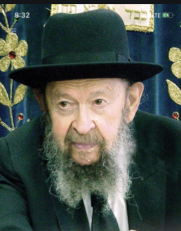

**QUESTION:** **Is there anything wrong with eating candies, cakes, doughnuts and things like that?**

**ANSWER:** The Rambam in his Hilchos Dei’os states that a man who is wise will eat what’s healthy for him, what’s beneficial. He says Don’t eat only things that your palate desires, like the dog and the donkey do (Hilchos Dei’os 3:2). You’re not an animal that eats only what it thinks is delicious to eat. You should eat only the things that are beneficial for you (ibid.).

So we see that following your desires means that you lack sense, like a donkey or a dog. Now, will we specify for you that candies and cakes are wrong to eat? It would be foolish for anybody to make such a rule. Sometimes a candy or a piece of cake is important to give you a lift; sometimes it’s not wrong. Many times people are down and they need a lift and then it’s recommended that they take a nosh and enjoy life a little bit more than the regular routine.

Yes, sometimes you can do things that are not not wrong to do, only that they’re not recommended, but you do it in order to raise your spirits. And for happy occasions too, sometimes people can be stimulated to a little more joy because of these things. Therefore, it requires discretion.

But ordinarily, things that are full of sugar will cause your teeth to rot unless you brush your teeth after eating them. And sometimes they take the place of the nourishing foods that you should be eating, and therefore it’s not sensible for a person to waste his efforts on nosherai.

And therefore, the wiser man is the one who chooses a diet that is healthy and nourishing. Not organic and special health foods; I don’t know about that. But foods that are healthful and nourishing and that people can get the most benefit from, that’s how a wise man should eat. You don’t need me to tell you; you know that yourself.

*Reprinted from an email of Toras Avigdor. - TAPE # 627 (January 1987)*

**Seeking Hashem – Part One**

**By Rabbi Moshe Meir Weiss**

In bentching, we declare “V’dorshei Hashem lo yachsiru chol tov – Those who seek Hashem will lack from naught that is good.” The occupation of seeking Hashem, being a Dorshei Hashem, is the fulfillment of one of the meanings of the verse, “Es Hashem Elokecha tirah,” for Rav Avigdor Miller renders this posuk, that “One should look to see Hashem in this world.” An example of such a person was Yisro, the father in-law of Moshe Rabbeinu.

The Torah quotes Yisro as saying, “Atah yadati ki gadol Hashem mikol elohim ki badavar asher zadu aleihem – Now I know that Hashem is greater than all powers, for that which the Egyptians plotted, befell them.” Yisro starts his comments with the words, “Now I Know.”

**Yisro was a True Dorshei Hashem**

This teaches us that Yisro was looking into this matter for a while. He was a true Dorshei Hashem. When Yisro saw that everything that happened to the Egyptians was measure for measure, he spotted conclusively the Hand of Hashem: When he saw the Nile which was filled with the blood of Jewish babies turn into blood by the plague of dam, when he noticed the Egyptians stricken with lice because they didn’t allow the Jews to bathe and to shower, and finally when he saw the Egyptians drown in the Red Sea for drowning the Jewish babies.

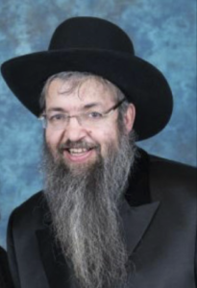

**Rabbi Moshe Meir Weiss**

All of this precluded any element of chance and pointed with a certainty to the Hand of Hashem. This pursuit of seeing Hashem is the goodly intelligence which we refer to every morning when we say “Reishis chochma yiras Hashem, seichel tov l’chol oseihem – It is the first of wisdom, awareness of Hashem, goodly intelligence for all that achieve it.”

**Hashem is Greater than all “Elohim”**

When Yisro saw that Hashem manipulated nature according to His will, he made the statement that Hashem is greater than all elohim. What does elohim refer to in this verse? We are taught that the word “Elohim” has the same gematria as HaTeva, nature. We are also taught that “Elohim” refers to Midas HaDin, the attribute of strict justice. I believe this is because nature acts strictly, brooking no compromise.

The sun is precisely 92 million miles away. If it were any closer, we’d be barbequed. If it were further, we would have an Ice Age. As we say in Kiddush Levana, “Chok u’zman nusan lahem shelo yeshanu es tafkidum – A statute in time Hashem gave them and they do not deviate from their purpose.” The sun is calibrated perfectly to give photosynthesis to every leaf on the planet. It is exactly just the right distance so that when we see there isn’t any sun glare but its light is also not too dim.

This is compared to Din, strict justice, which allows for no wavering. Yisro took note that when Hashem manipulated the world doing the ten plagues and the splitting of the Red Sea, He was greater than all of this nature.

Now however, for us to be Dorshei Hashem, we don’t need the manipulation of nature. By studying the din of the teva, we can see clearly the Hand of Hashem: simply by looking at a chicken egg whose shell is constructed in just the right thickness. If it were a little thinner, the young chick wouldn’t survive the trauma of the egg birth. But if the shell were a little bit harder, the chick wouldn’t be able to peck its way out. It has to be just the right thickness.

**A Lesson from the Ostrich’s More Traumatic Birth**

Now, because the ostrich has a more traumatic birth, its egg shell is therefore a lot harder. However, the baby ostrich has a thorn-like appendage on one of its fingers so that it can break through the shell and exit to the world. “Mah rabu maasecha Hashem, kulam b’chochma asisa – How great are your deeds Hashem, all invested with great wisdom.”

Let’s take another example: before a fetus is born, the blood doesn’t flow to the lungs for the baby is not using its lungs. Rather, it “breathes” using the umbilical cord. Instead, the blood flows from the right side of the heart to the left side of the heart through a specially designed duct.

At the moment of birth, this duct amazingly and instantaneously seals and instead the blood starts flowing to the lungs. This happens when every baby is born. The true seeker of Hashem does not have far to look to discover the plan and purpose of the Creator everywhere he or she looks.

May it be the will of Hashem that we learn to see Hashem through the myriads of kindness which He showers upon us.In that merit, may He bless us all with long life, good health and everything wonderful.

*Reprinted from the January 13, 2021 email of The Jewish Vues.*

**Rabbi Berel Wein on**

**Parshat Beshalach 5781**



This week we read in the Torah the final chapter of the liberation of the Jewish people from Egyptian bondage and slavery. After centuries of servitude, the children of Jacob are finally freed from their Egyptian taskmasters and embark on their journey of building a civilization.  Yet, the Torah goes to great lengths to point out to us that freedom as a concept cannot exist in a vacuum.

The people must have food to eat and water to drink. Though the Jewish people will live for 40 years in an unnatural environment in the desert of Sinai, they do not escape the constant necessities of human life. The L-rd will provide these necessities through miracles – bread from heaven and water from the flint rock. These miracles, perhaps like all other miracles, will require human participation – the gathering of the heavenly bread that falls to the earth, and the striking of the rock to force it to give forth waters.

It can be asked that if L-rd is performing miracles for the Jewish people anyway, then why aren’t the miracles complete, why are they always somehow dependent upon human action as well? The answer to that question lies in the question itself. The adage that G-d helps those who help themselves is a basic tenet and value in Judaism. Miracles provide opportunities, but these, like all opportunities, must be initiated by humans for them to be beneficial and effective.

It is  difficult for the Jewish people over the 40-year sojourn in the desert of Sinai to appreciate their newfound freedom. People become accustomed to almost anything, and this includes slavery and servitude. An independent people create their own society, provide their own needs and continually jostle in a contentious world to retain that freedom.

A people accustomed to slavery will find this to be particularly challenging. Slavery induced in their minds and spirit a false sense of regularity that bordered upon security. The president of the United States once remarked that if one wants to be certain of having three meals a day, then one should volunteer to spend the rest of one's life in prison. He will receive this throughout his incarceration.

In the story of the Jewish people in the desert, when faced with difficult circumstances and upsetting challenges, there was always the murmur that they should return to Egypt and ‘go back to prison’, for at least then hey would be certain of having their three meals a day.

According to many Torah commentaries, this was the fundamental reason why the generation that left Egypt could not be the generation that would enter and conquer the land of Israel and establish Jewish independence in their own state and under their own auspices.

Psychologically they were not ready to be a free people with all the burdens that accompany freedom and independence. They could accept the Torah, be intellectually religious, admire Moshe and believe in the Almighty. But they were unable to free themselves from the psychological shackles of Egyptian bondage. And there are no miracles that can do that for human beings. Only human beings can do that for themselves.

*Reprinted from the current website of Rabbiwein.com*

**Parshas Beshalach**

**The Merit of Trusting HASHEM**

**By Rabbi Bentzion Shafier**

**Founder of TheSmuz.com**

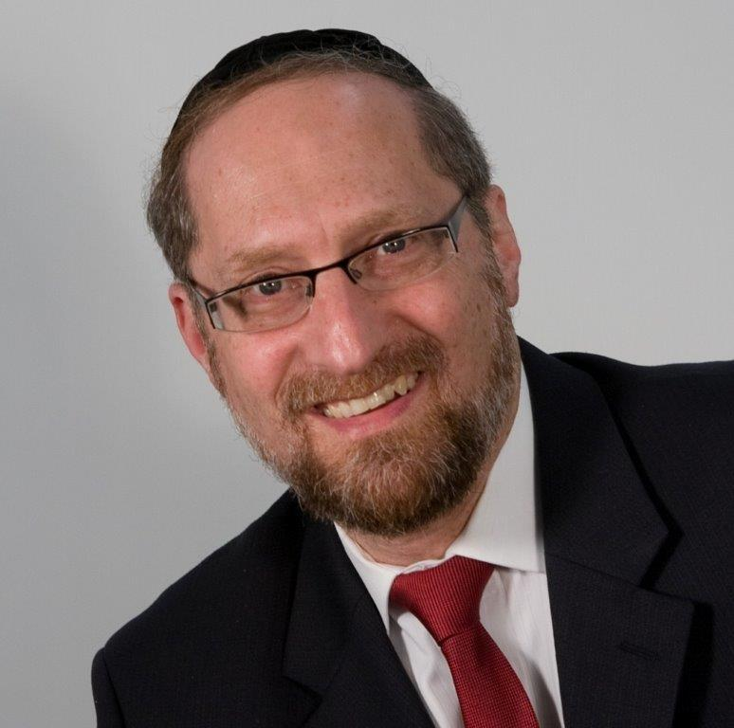

*And HASHEM said to Moshe, “Why shout at Me? Speak to the Jewish People and they should cross.* Shemos 14:15

After months of witnessing the hand of HASHEM, the entire Jewish nation — three million strong — marched out from slavery to freedom with flourish and fanfare.

Escorted by clouds of glory, walking through a desert made smooth by overt miracles, they travelled as one. It seemed that the troubles of the Jewish people were finally behind them, and they were being escorted to their final redemption . . . until the clouds directed them to a dead end – the sea.

Stopping there, the Jewish people looked up and saw Mitzraim chasing after them. With nowhere to turn, they waited while Moshe called out to HASHEM. HASHEM answered back, “Moshe, why do you cry out to Me? Speak to the Jewish people and let them travel.” At that point, the entire nation crossed the Yam Suf.

Rashi is bothered by the expression that HASHEM used: “the Jews need only travel.” What did HASHEM mean by that? How could they travel when an entire sea was in the way? Rashi explains that HASHEM was saying there is nothing that will stop the Klal Yisroel because they are worthy of the greatest miracles ever known to man. Rashi then enumerates the reasons that they are so worthy. 1. The merit of the Avos. 2. Their own merit. 3. The merit of the trust that they had in HASHEM at that moment.

**How is Trusting in HASHEM**

**A Merit Equal to the Avos?**

The difficulty with this Rashi is that he lists all three reasons in same breath as if they are equal, and clearly they aren’t. The first two, the merit of the Avos and the Jews’ own merit, refer to overall perfection across the gamut of human activity. The Avos were living, breathing Sifrei Torah. We learn from their every action and thought. Their combined merit is hard to imagine. And even the second cause, the merit of the entire Jewish people, was stupendous. While not every member had remained on the highest level, as a nation they had remained loyal to HASHEM.

After spending months witnessing HASHEM’s direct involvement in their lives, they had grown to great levels across many different areas: chessed, emunah, ahavas Yisroel, emes… How can we compare one single aspect — their trust in HASHEM — to the merit of the Avos or to the merit of all of their actions put together? It would seem to be dwarfed by comparison. Yet Rashi put these together as if they are all equal reasons that HASHEM would create miracles for the Jewish people.

**HASHEM’s Involvement in the World**

The answer to this question is based on understanding HASHEM’s relationship to this world. The Chovos Ha’Levovos explains that because HASHEM created this world, HASHEM feels a responsibility, if it could be, to sustain it. Much like if I invite you to my home it is my obligation as host to take care of your needs, so too HASHEM feels almost obliged to support all of His creations. However, there are different levels to HASHEM’s direct involvement in the running of this world, what the sefer Derech Hashem calls “hashgacha klalis” and “hashgacha pratis.”

Hashgacha klalis, or **general intervention**, refers to HASHEM’s involvement in the “big picture” issues: famine, war, epidemics, natural catastrophes, and maintaining the multitude of systems that allow for life as we know it. It is a given that HASHEM is constantly and permanently involved in the running of this world at that level. However, the specific details and the day-to-day running of the world HASHEM has given over to a host of forces that He created and maintains, but allows to actually carry out the laws that He set. These forces determine much of the outcomes that befall humanity.

Hashgacha Pratis, or **personal intervention,** is very different. This refers to HASHEM’s personal involvement in a nation’s or a person’s life. It includes HASHEM actually supervising directly, watching over and taking care of the needs of those individuals.

General intervention is a given; it is something that HASHEM assures to all of creation as a birthright. Personal intervention is quite different; it must be earned. By dint of being the children of the Avos, the Jewish nation merits personal intervention — provided they keep certain conditions.

One of these is that they must recognize Who runs the world. In this regard, it functions on a continuum. The more a person trusts in HASHEM, the more, if it could be, HASHEM feels an obligation to take care of that person, and the more HASHEM will be directly involved in that person’s life. It is almost as if HASHEM says, “How can I not take care of him, he relies on Me, he trusts in Me.

This seems to be the answer as to why the “merit of their belief in HASHEM” was so pivotal at Krias Yam Suf. In terms of the objective weight, there is no comparison between the merits of the Avos and their current trust in HASHEM, but trust in HASHEM operates on a different level. It alone can be the reason that HASHEM will save a people. It was almost like HASHEM was saying, “How can I not take care of them? They trust in Me. They rely on Me. I have to save them.” And that trust alone was reason enough to split the sea.

**The**

**Reward for Trust – HASHEM Takes Care of Us**

This is a powerful lesson to us in the effect of trusting in HASHEM. While we are obligated to act in the ways of this world, we are equally obligated to trust in HASHEM. We have to go out and do our part, follow the laws of nature, knowing all the while that exactly that which HASHEM has decreed will come about — no more, no less, no sooner, no later.

However, the amount of our trust in HASHEM will directly affect how much HASHEM will intercede on our behalf, and this may have a huge difference in many situations. For example, there may be times when we don’t warrant receiving that which we need.

Whether it’s health, success, or sustenance, it may well be that according to the letter of the law, we don’t special assistance, and certainly not the right to ask HASHEM to intervene on our behalf. In that situation, it may be our trust in HASHEM alone that will bring us HASHEM’s help. When we rely on HASHEM and trust in Him, HASHEM, if it could be, thereby feels almost obligated to take care of us.

Trust in HASHEM is the basis of our belief system. It is also one of the most comforting thoughts that a human can come to. And it is also one of the most effective ways for us to secure HASHEM’s direct involvement in our lives — even in a manner that we might not otherwise deserve.

## Why should their trusting in HASHEM be a reason to split the sea?

*Reprinted from the website of Theshmuz.com.*

**Thoughts that Count**

*And Moses took the bones of Joseph with him* (Ex. 13:19)

In the Midrash, Moses is described as "wise of heart" for concerning himself with Joseph's bones when the rest of the Jews were helping themselves to the riches that were washed up on the shores of the Sea. This is obviously a pious deed, but what does it have to do with wisdom?

Moses, as leader of the Jewish people, was like the kohanim (priests) when it came to the prohibition against defiling oneself with the dead. However, by waiting until everyone else was busy, Moses was permitted to do so (indeed, it was a great mitzva), as no one else was free to attend to the task. *(Pardes Yosef)*

*See, the L-rd has given you the Shabbat* (Ex. 16:29)

Some things are beyond man's ability to control, but the extent to which a person feels the sanctity of Shabbat is dependent on his own service. The more a Jew prepares and invests his efforts, the more the holiness of Shabbat is felt. *(Likutei Torah)*

*Reprinted from the Parshat Beshalach 5756 edition of the L’Chaim Weekly, a publication of the Lubavitch Youth Organization.*

**The Obligation to Blot Out**

**The Memory of Amalek**

**From the Talks of the Lubavitcher Rebbe**

**Rabbi Menachem Mendel Schneerson, Zt”l**

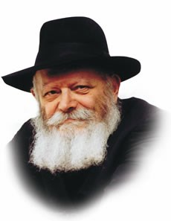

This week's Torah portion, Beshalach, speaks about the perpetual battle the Jewish people was commanded to wage against Amalek. "Because G-d has sworn by His throne, that the L-rd will have war with Amalek from generation to generation."

The Targum of Yonatan ben Uziel (a translation of the Bible into Aramaic, the Jewish vernacular of ancient times) explains that the war against Amalek will end only when Moshiach comes and ushers in the Messianic age.

Nowadays we do not know the physical identity of Amalek; only Moshiach will be able to correctly distinguish between who is, and who is not, one of his descendants. Thus, at present, we are unable to fulfill the mitzva in the literal sense.

Nonetheless, the commandment to "blot out the memory of Amalek from under heaven" is still incumbent on us today, albeit in the spiritual sense.

"Amalek," in terms of our spiritual service of G-d, is symbolic of coldness and apathy for all that is holy. Of Amalek it is said, "He cooled you off" -- i.e., the physical Amalek dampened Israel's eagerness and enthusiasm for the Torah they were about to receive at Sinai following the exodus from Egypt; the spiritual Amalek lurks in the recesses of our hearts.

G-dliness and holiness are warm and filled with life and vitality; apathy and indifference are cool and unresponsive.

"All right," the spiritual Amalek whispers in our ears, "you want to observe the Torah's commandments? Fine! Every Jew should do so. But why be all excited about it? It's not as if you're doing something new, something you've never done before. Every day you learn Torah, every day you recite your prayers. What's the big deal?"

**Cooling Off the Affinity of Jews for Holiness**

In this way (as well as in many other subtle ones) Amalek attempts to cool off the Jew's innate ardor and natural affinity for holiness. His aim is to blind him to the true reality: that a Jew's performance of a mitzva is the single most significant act that can ever be accomplished in this world, one which affects his entire being forever and ever.

The crafty Amalek is ever vigilant and resourceful when it comes to tricking a Jew into adopting a ho-hum attitude towards sanctity and G-dliness.

How are we to fight this incursion of coldness? By responding with warmth and emotion, consciously resisting Amalek's attempt to cloud our eyes to the truth.

Furthermore, waging war against Amalek in the spiritual sense serves to prepare us for the era in which we will be able to do so in the physical sense -- the age of our Righteous Moshiach, may it commence immediately.

*Reprinted from the Parshat Beshalach 5756 edition of the L’Chaim Weekly, a publication of the Lubavitch Youth Organization. Adapted from Sefer HaSichot of the Rebbe, Vol. 2.*

******************************************************************

**See, the L-rd has given you the Shabbat (Ex. 16:29)**

Some things are beyond man's ability to control, but the extent to which a person feels the sanctity of Shabbat is dependent on his own service. The more a Jew prepares and invests his efforts, the more the holiness of Shabbat is felt. *(Likutei Torah)*

*Reprinted from the Parshat Beshalach 5756 edition of the L’Chaim Weekly, a publication of the Lubavitch Youth Organization.*

**Larry King's**

**Enormous Heart**

**By**[**Rabbi Irwin Katsof**](https://www.aish.com/authors/51470182.html)

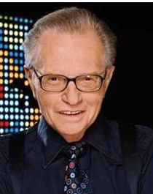

*Behind the glitz of Hollywood, Larry was a kind, caring soul who recognized his Jewish roots and used his fame to help the Jewish people.*

I met Larry King in 1995. Together with my production colleague Lou Rudolph, Aish Hatorah was attempting to launch an international satellite broadcast to bring awareness to the Jewish community about the plight of Soviet Jews. It was called “Help our People Know” and it was failing dismally.

**A Chance to Meet Larry King**

Then a friend of Lou’s announced she had bumped into Larry King at the hair dresser at the Beverly Wilshire hotel and asked him if he'd meet her rabbi about a project to help Russian Jews. He said sure and minutes later we were racing over to the hotel. On the way to his room, I asked Lou, "What should we ask him?”

"Ask him to be the on-air host of the satellite broadcast."

**Petrified at Asking for His Help**

I was petrified. *I am going to ask Larry to host the broadcast of a small, and at the time, relatively unknown organization?* We had 100 people signed up. Larry had one million plus viewers a night. You've got to be kidding. There was no way he'd agree to go on air with us.

We walked into his suite. I will always remember his warm, gracious welcome. He bellowed from his arm chair, "Rabbi, how can I help you?”

I muttered softly and in embarrassment, "Well we have this idea of an international broadcast to help Soviet Jews. Would you be the on-air host?"

**“What Else Can I Do for You?”**

"Of course," he replied. "What else can I do for you?"

Ten minutes later he had called Jeffrey Katzenberg, Chairman of Dreamworks and Sumner Redstone, Chairman of Paramount Studios and gotten them to agree to be the Co- Chairmen and to give us a sound stage at Paramount studios to produce the broadcast. As they say in Hollywood, the rest is history. The project took off and raised over one million dollars.

This was the first of many projects Larry would undertake to help the Jewish people and Aish HaTorah.

**Cannot Recall His Ever Saying No**

I cannot recall him ever saying no to anything I asked of him.

“Larry, we want to bring a group of leading American Jewish businessmen on a mission to Israel. Would you lead the mission?”

"Of course, Rabbi. Done. What else can I do for you?"

That trip ended up including Howard Schultz, Founder of Starbucks, Barry Sternlicht, Chairman of Starwood Hotels, the world's largest hotel group at the time, Lady Margaret Thatcher, the co-founder of AOL, and then Senator Joe Biden.

“Larry, We would like to bring them to meet with the Prime Minister of Israel. Would you arrange it for us?”

"Of course Rabbi, done. What else can I do?"

“Larry, we would like to hold a gala dinner in the Knesset. Can you arrange this for us?”

"Of course Rabbi, done. What else?"

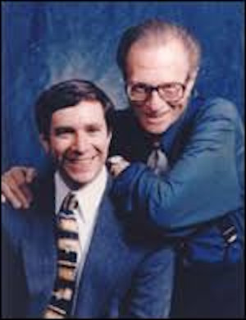

*Irwin Katsof and Larry King*

“Larry, we'd like to bring this group on the first-ever visit to meet with King Hussein of Jordan, in the Palace. Can you call King Hussein and make this happen?"

"Of course, Rabbi. My pleasure. Done."

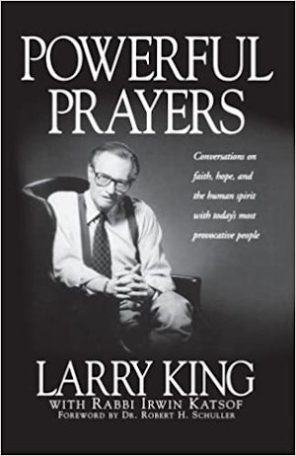

Behind the scenes, quietly and with little fanfare Larry, who I always called by his Hebrew name, Leibel Zeiger, was working for the Jewish people. He was not afraid to ask others to help and he was even eager to use his fame and name recognition to do good. There was a spark deep within him that acknowledged his Jewish roots and wanted a connection with his people.

When I reflect on all that he did to help our outreach efforts, I am in awe of the power of the "pintele Yid" -- that Jewish spark resting within us all, just waiting for the right conditions to be brought back to life. Larry was steeped in Hollywood but his Jewish soul was yearning to be ignited.

He would often tell me he was an atheist but he respected people who had faith. We discussed belief in G-d. I suggested we write a book together about famous people and their journeys to G-d and spirit. Naturally, he agreed. Out of this was born “[Powerful Prayers: Conversations on faith, hope and the human spirit with today’s most provocative people](https://www.amazon.com/Powerful-Prayers-Conversations-Spirit-Provocative/dp/1580630863/friendsofaishhat)."

We interviewed 100 famous people about their connection to G-d and prayer and the role G-d played in their life. It made Publisher Weekly’s ten bestselling religious books of the year. It sold over 130,000 copies.

**Their Belief in G-d Touched Larry**

In the book we interviewed everyone from the Dalai Lama to Karim Abdul Jabbar, from President Bush to Prime Minister Peres. Their belief and trust in G-d touched Larry deeply. It was a struggle for him to change his position on G-d, but it gave him pause and caused him to reflect about his Jewish roots.

We would study Torah together. He agreed to a meeting with [Rabbi Noah Weinberg](https://www.aish.com/rn/). He was

moved by Rabbi Weinberg’s big energy and promised to help him.

We talked with him about the power of the Jewish people and he talked fondly of his roots in Brooklyn and of his grandparents in Eastern Europe.



***Larry King wearing tefillin***

I will always remember Larry for his enormous heart and his willingness to help the Jewish people. His life touched mine and the book we wrote together reached tens of thousands and helped them examine their connection to G-d.

Behind the glitz of Hollywood, Larry was a kind, caring soul who recognized his Jewish roots and used his fame to help the Jewish people. I appreciate all he did for me. He helped make the world better and will be missed by myself and many across the globe.

*Reprinted from the January 24, 2021 website of Aish.com Larry King passed away on January 23, 2021 at the age of 87 from complications of Covid-19.*

**Shabbat Shira**

Every year on Shabbat Parshat Beshalach, the Maharal of Prague would instruct the teachers to gather their students (and their parents) in the courtyard of the synagogue to tell them the story of how the birds sang and danced during the splitting of the Sea. As related in the Midrash, the Jewish children plucked fruit from the branches of the trees that sprang up on either side and fed them to the birds.

After the story was told, kasha (groats) was distributed to the children to scatter about for the birds and chickens in commemoration of this event.

The Maharal would then bless the children and their parents that they raise them to a life of Torah and good deeds and lead them to the marriage canopy.

*Adapted from (Sefer HaSichot 5702 of the Previous Rebbe)*